**K L UNIVERSITY**

**COMPUTER SCIENCE ENGINEERING DEPARTMENT**

**A Project Based Lab Report**

**Of**

**CURRENCY CONVERTER**

**SUBMITTED BY:**

I.D NUMBER NAME

180030149 SHRUTI.S

180030646 P.SIVA

180030651 T.NITHISH CHANDRAVYAS

180031315 B.R.PAVAN KALYAN

**UNDER THE ESTEEMED GUIDANCE OF**

**SASIDHAR**

**ASSNT PROFESSOR**



**KL UNIVERSITY**

Green fields, Vaddeswaram – 522 502

Guntur Dt., AP, India.

**DEPARTMENT OF BASIC ENGINEERING SCIENCES**



**CERTIFICATE**

This is to certify that the project based laboratory report entitled “CURRENCY CONVERTER” submitted by Mr./Ms**. SHRUTI.S,V.MOHIT KRISHNA REDDY,T.NITHISH CHANDRAVYAS, B.R.PAVAN KALYAN** bearing Regd. No. 180030149,180031217,180030651,180031315 to the **Department of Basic Engineering Sciences, KL University** in partial fulfillment of the requirements for the completion of a project based Laboratory in “OBJECT ORIENTED PROGRAMMING” course in II B Tech III Semester, is a bonafide record of the work carried out by him/her under my supervision during the academic year 2019 – 2020.

PROJECT SUPERVISOR HEAD OF THE DEPARTMENT

< GUIDE NAME>

**ACKNOWLEDGEMENTS**

It is great pleasure for me to express my gratitude to our honorable President **Sri. Koneru Satyanarayana**, for giving the opportunity and platform with facilities in accomplishing the project-based laboratory report.

I express the sincere gratitude to our principal for his administration towards our academic growth.

I express sincere gratitude to our Coordinator and HOD-BES for his leadership and constant motivation provided in successful completion of our academic semester. I record it as my privilege to deeply thank for providing us the efficient faculty and facilities to make our ideas into reality.

I express my sincere thanks to our project supervisor <name> for his/her novel association of ideas, encouragement, appreciation and intellectual zeal which motivated us to venture this project successfully.

Finally, it is pleased to acknowledge the indebtedness to all those who devoted themselves directly or indirectly to make this project report success.

NAME ID NUMBER

SHRUTI.S 180030149

P.SIVA 180030646

T.NITHISH CHANDRAVYAS 180030651

B.R. PAVAN KALYAN 180031315

**ABSTRACT**

The project is about the feedback that is given by students about the faculty. The feedback for teachers for different sections and students are different. this data in a separate file such that each section has its own separate file from which he can retrieve the data anytime. This is done by using a GUI (Graphical User Interface) .

A GUI of an application built using [Java](https://www.thoughtco.com/what-is-java-2034117) is made up of layers of containers. The first layer is the window used to move the application around the screen of your computer. It is a top-level container that gives all other containers and graphical components a place to work in.  In this, the components of GUI used are Button , Textfield and label.

**INDEX**

|  |  |  |
| --- | --- | --- |
| **S.NO** | **TITLE** | **PAGE NO** |
| 1 | Introduction | 6 |
| 2 | Aim of the Project | 7 |
| 3 | Software & Hardware Details | 8 |
| 4 | Algorithm for each module | 9 |
| 5 | Implementation | 10 |
| 6 | Integration and System Testing | 15 |
| 7 | Conclusion | 17 |

**INTRODUCTION**

A **currency converter** is software code that is designed to convert one [currency](https://en.wikipedia.org/wiki/Currency) into another in order to check its corresponding value. In order to convert one currency into another, a user enters an amount of money (e.g. '1000') and chooses the currency he/she wishes to check the monetary value of (e.g. '[United States Dollar](https://en.wikipedia.org/wiki/United_States_Dollar)'). After that, the user selects one, or sometimes several other currencies, he/she would like to see the result in. The [application software](https://en.wikipedia.org/wiki/Application_software) then calculates and displays the corresponding amount of [money](https://en.wikipedia.org/wiki/Money).

**AIM**

The main aim of this project is to create a GUI which would contain the amount to be converted, converted amount into , country of the amount to be converted and the other country of which the amount would be converted to. Then using file operations we would save all the information that was calculated using this currency converter into a file. And by using mathematical operations the amount would be calculated according to the required country selected.

**SYSTEM REQUIREMENTS**

* **SOFTWARE REQUIREMENTS:**

The major software requirements of the project are as follows:

Language : Java

Operating system**:** Windows Xp or later.

* **HARDWARE REQUIREMENTS:**

The hardware requirements that map towards the software are as follows:

RAM : 8GB

Processor :64-bit processor

**ALGORITHM**

Step 1 : Create a JFrame.

Step 2 : Create a JTextfield.

Step 3 : Create a JLabel for providing input of subjects.

Step 4 : Create JLabels for asking the feedback questions.

Step 5 : Create Jbuttons for choosing and submitting the feedback.

Step 6 : Create JComboboxes for the subject to be selected and the teacher to be given feedback.

**IMPLEMENTATION**

import java.io.*;  
import javax.swing.*;  
  
  
import java.awt.*;  
import java.awt.event.*;  
import java.io.FileWriter;  
import java.io.IOException;  
  
public class Cconversion {static double cur1=1;  
static double cur2=71.4285;  
static double cur3=0.0603;  
static double cur4=10;  
static double cur5=0.6493;  
static double cur6=47.619;  
static double cur7=232.5581;  
static double cur8=16.9491;  
static double cur9=18.8679;  
static double cur10=0.3891;  
  
public static double check(int a)  
{  
 switch(a)  
 {  
   case 1:return cur1;  
   case 2:return cur2;  
   case 3:return cur3;  
   case 4:return cur4;  
   case 5:return cur5;  
   case 6:return cur6;  
   case 7:return cur7;  
   case 8:return cur8;  
   case 9:return cur9;  
   case 10:return cur10;  
   default: return -1;  
 }  
}  
static int c=0,a1,a2,a3,i;  
static double d1,d2,d3,d4;  
static String s1,s2,s3,s4,s,s5;  
public static void main(String[] args)throws IOException  
{  
  
 String[] Country= {"Select One","INDIA","USA","SOUTH KOREA","CHINA","JAPAN","AUSTRALIA","KUWAIT","MALAYSIA","QATAR","SRILANKA"};  
 Dimension screenSize = Toolkit.getDefaultToolkit().getScreenSize();  
   
 JFrame f=new JFrame("CURRENCY CONVERTER");  
 f.setSize(screenSize.width/2, screenSize.height/2);  
 f.setLayout(null);  
 f.setVisible(true);  
  
 JLabel lb1=new JLabel("Amount to be converted");  
 lb1.setBounds(450,50,800,50);  
 lb1.setFont(new Font("Segoe Print", Font.BOLD,60));  
 f.add(lb1);  
   
 JTextField tf1=new JTextField();  
 tf1.setBounds(550,120,400,50);  
 f.add(tf1);  
  
 JComboBox<String> CountryList1 = new JComboBox<>(Country);  
 CountryList1.setBounds(200,300,300,50);  
 f.add(CountryList1);  
   
 JLabel lb2=new JLabel("Converted amount");  
 lb2.setBounds(500,500,800,50);  
 lb2.setFont(new Font("Segoe Print", Font.BOLD,50));  
 f.add(lb2);  
  
 JTextField tf2=new JTextField();    
 tf2.setBounds(550,600,400,50);  
 f.add(tf2);  
  
 JLabel lb3=new JLabel("Amount to be converted from");  
 lb3.setBounds(50,220,800,50);  
 lb3.setFont(new Font("Segoe Print", Font.BOLD,40));  
 f.add(lb3);  
  
 JLabel lb4=new JLabel("Amount to be converted into");  
 lb4.setBounds(900,220,800,50);  
 lb4.setFont(new Font("Segoe Print", Font.BOLD,40));  
 f.add(lb4);  
   
 JButton b1=new JButton("Convert");  
 b1.setBounds(550,400,400,50);  
 f.add(b1);  
   
   
 JComboBox<String> CountryList2 = new JComboBox<>(Country);  
 CountryList2.setBounds(1000,300,300,50);  
 f.add(CountryList2);  
   
 CountryList1.addActionListener(new ActionListener()  
{    
  public void actionPerformed(ActionEvent e)  
{  
      a1=CountryList1.getSelectedIndex();  
      if(a1!=0)  
      d1=check(a1);  
      else  
      tf2.setText("Select country properly");  
}  
  
});  
  
  
   
 CountryList2.addActionListener(new ActionListener()  
{    
  public void actionPerformed(ActionEvent e)  
{  
   a2=CountryList2.getSelectedIndex();  
   if(a2!=0)  
   d2=check(a2);  
   else  
      tf2.setText("Select country properly");        
}  
  
});  
  
   
   
 b1.addActionListener(new ActionListener()  
{    
  public void actionPerformed(ActionEvent e)  
{  
   c=0;  
        d3=Double.valueOf(tf1.getText());  
        d4=(d1/d2*d3);  
        s1=String.valueOf(d3);  
        while(s1.length()!=29)  
        {  
           s1 = s1.concat(" ");  
        }  
        s2 = CountryList1.getSelectedItem().toString();  
        while(s2.length()!=31)  
        {  
        s2 = s2.concat(" ");  
        }  
        s3 = CountryList2.getSelectedItem().toString();  
        while(s3.length()!=30)  
        {  
        s3 = s3.concat(" ");  
        }  
        s4=String.valueOf(d4);  
         
        tf2.setText(String.valueOf(d4));  
        try {  
            File file=new File("currency1.txt");  
FileWriter fr=new FileWriter(file,true);  
FileReader fre=new FileReader(file);    
   BufferedReader br = new BufferedReader(fre);  
if (file.length() == 0)  
{  
            fr.write("[S.NO](http://s.no/)        Amount to be converted       coverted from Country          converted to Country          Convereted Amount\n\n");  
c=2;  
}  
else  
{  
while((s=br.readLine())!=null)      
       {  
          c++;                  
       }  
}  
s5=String.valueOf(c/2);  
while(s5.length()!=12)  
       {  
        s5 = s5.concat(" ");  
       }  
fr.write(s5+s1+s2+s3+s4+"\n\n");  
fr.close();  
br.close();  
} catch (IOException e1) {  
System.out.println("File Not working properly \n");  
}  
         
         
}  
  
});    
}  
}

**INTEGRATION AND SYSTEM TESTING**

OUTPUTS

Screen Shots:

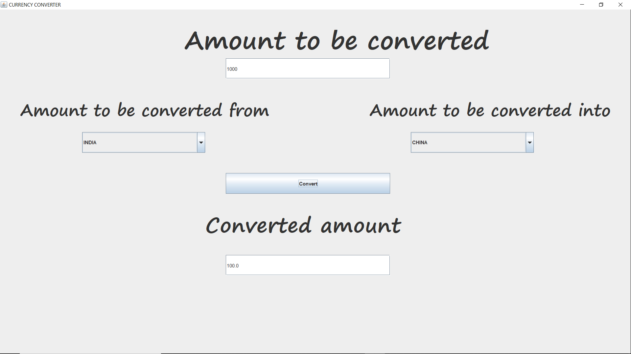

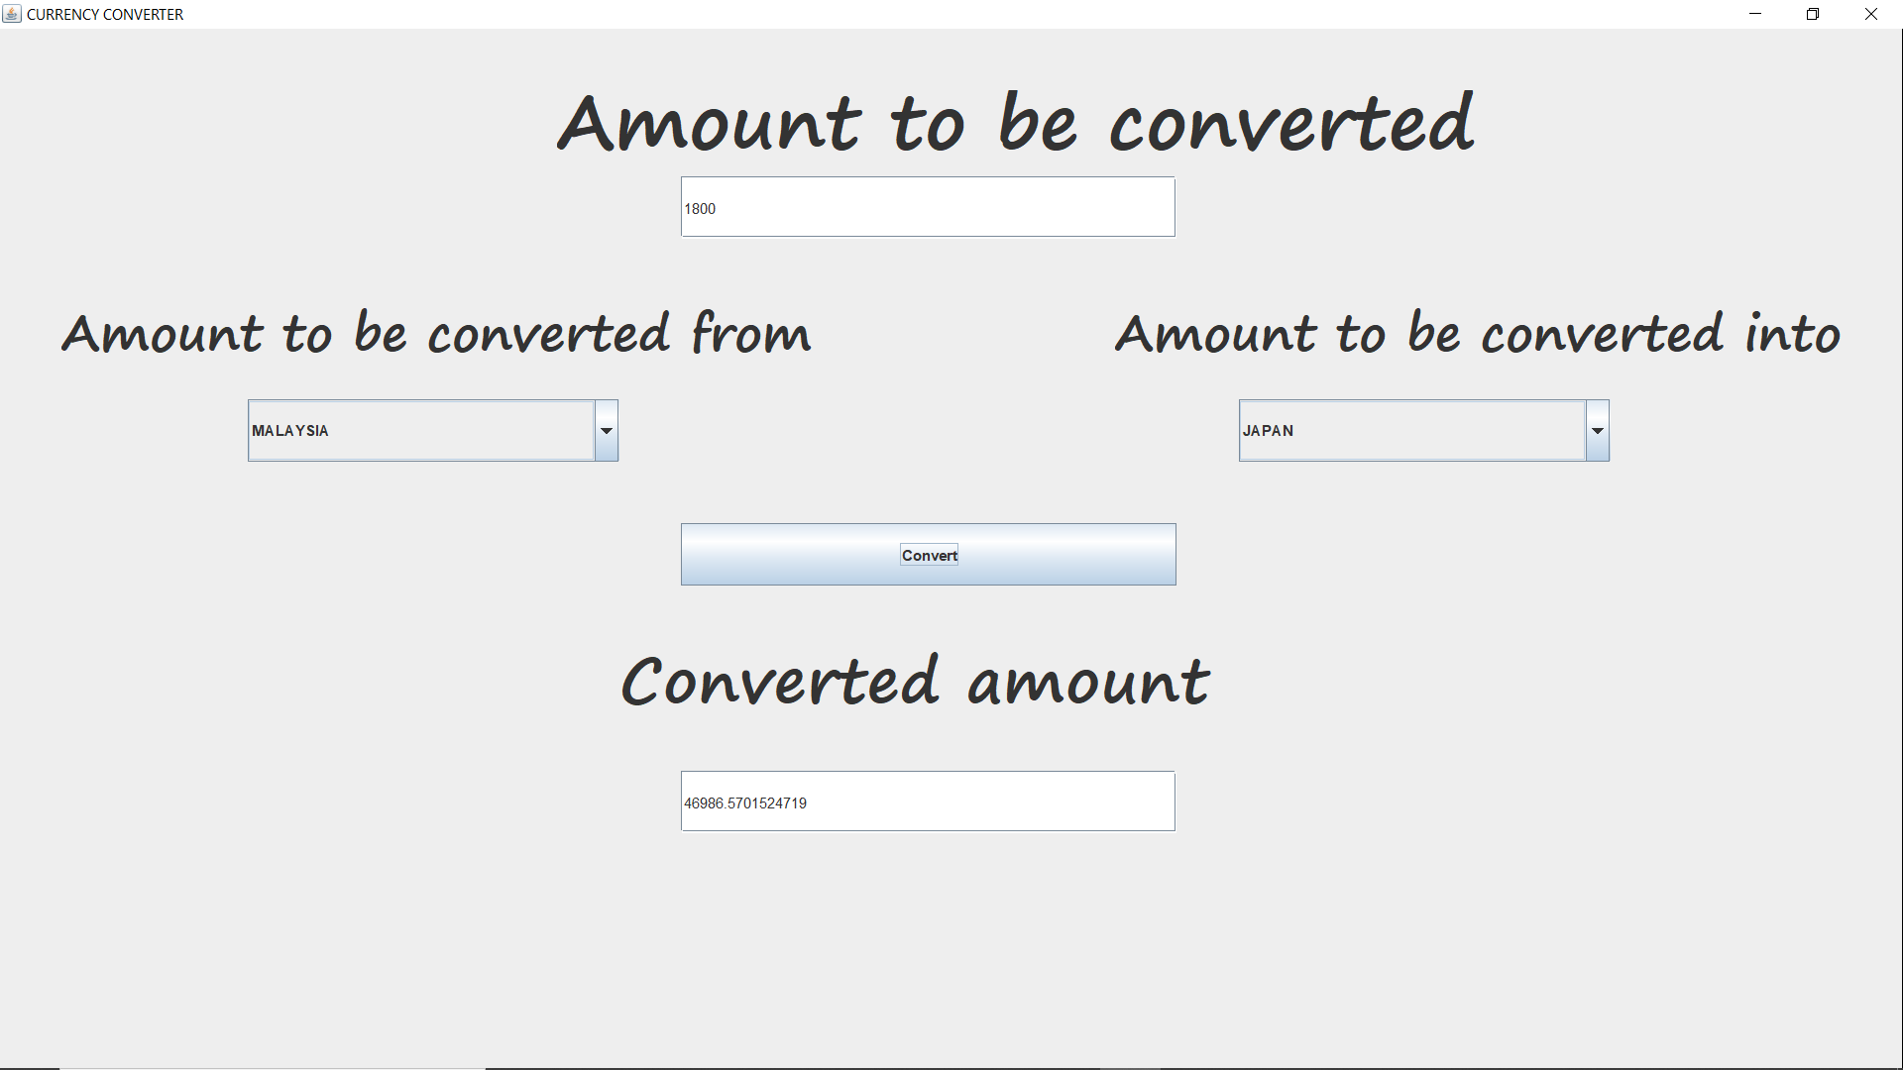

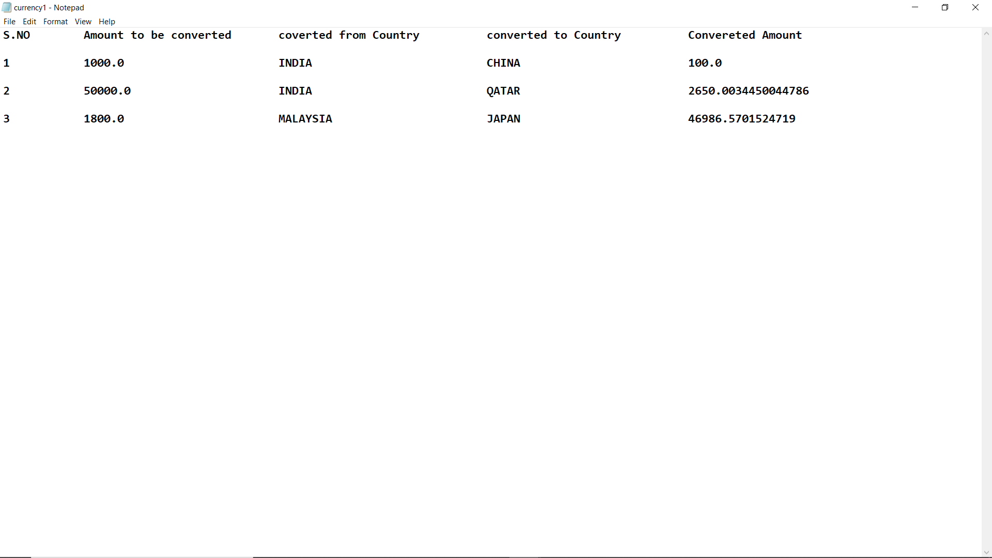

**CONCLUSION**

We successfully developed a GUI and by using file operations and calculations we have reached our goal of converting amount from one country to another without any mistakes.